
CSA15 – CLOUD COMPUTING AND BIG DATA ANALYTICS
ASSIGNMENT 1 – CO1
Design, Analyse and Validate a Cloud-Based Solution for Migrating a Legacy University Management System
Smart Campus Cloud Migration: Tasks 1 to 11 including the Day-4 Design Challenge
CO1: Apply cloud computing technologies including hardware–software evolution, virtualization, web services, and service models to develop cloud-based solutions.
Student Name | Hariny A P
Register Number | 192511334
Department / Section | B.E. CSE
Academic Year / Semester | 2025-2026
Faculty Name | Dr. Antony Joseph Rajan D
Submission Date | 05-11-2026
Nature of Assignment: Individual | Total Marks: 50

Table of Contents
Introduction and University Scenario 3
Task 1: Introduce Cloud Computing and Map It to the Scenario 3
1.1 Definition and Characteristics 3
1.2 Deployment Models and Problems Addressed 4
Task 2: Trace the Evolution and Hardware Evolution 5
Task 3: Analyse Internet Software Evolution 6
Task 4: Apply Server Virtualization 7
Task 5: Apply Web Services 8
Task 6: Analyse the Service Models: IaaS, PaaS and SaaS 10
Task 7: Examine XaaS 11
Task 8: Design the Cloud Solution Architecture 12
Task 9: Hands-on Implementation and Documentation 14
Task 10: Evaluate and Recommend the Final Solution 18
Task 11: Re-evaluate and Adapt the Design (Day-4 Design Challenge) 21
11.1 Impact Analysis 21
11.2 Evaluation of the Original Design 21
11.3 Adaptation 22
11.4 Evidence-Based Defence 23
Overall Conclusion 24
References 24

Introduction and University Scenario
This report answers all eleven tasks of CSA15 Assignment 1 (CO1) as a cloud consultant to a multi-campus university leaving an ageing data centre. It keeps the original task numbering, and later tasks reuse the same sizing, service models and assumptions so that the architecture (Task 8), proof-of-concept (Task 9), cost model (Task 10) and Day-4 redesign (Task 11) agree with one another. The university runs an SIS, LMS, Library System, Exam Portal and Email on 12 dedicated physical servers (about 15% average CPU, above 95% at peaks), for about 25,000 students and 2,000 staff on four campuses, with monolithic applications, 6–8 week procurement and no disaster recovery.
Table I.1
ID | Assumption | Used in
A1 | 12 servers = SIS ×3 (web, application, database), LMS ×3, Library ×1, Exam Portal ×2, Email ×2, directory/backup ×1. Each has 16 cores and 64 GB RAM, about 30% of RAM actively used. | T4, T6
A2 | Peaks last 9 weeks a year (admissions 3, results 2, exams 4) = 63 days = 1,512 hours. | T4, T10, T11
A3 | Current peak is 200 requests per second (req/s), a normal day 25 req/s; one 2-vCPU container serves 12 req/s and is run at no more than 70%. | T8, T11
A4 | Each of 40 colleges adds about 1,500 students (60,000), so students grow from 25,000 to 85,000 (3.4×). | T11
A5 | Money is in ₹ lakh (1 lakh = 100,000), constant prices, undiscounted, excluding tax; unit prices are indicative and need provider quotations. Component availabilities follow typical SLA classes (99.9%–99.99%). All names and records are fictitious. | T10, T11
A6 | Student data is personal data under the DPDP Act, 2023 (Government of India, 2023); production and DR data stay in Indian regions. | T1, T10

Task 1: Introduce Cloud Computing and Map It to the Scenario

1.1 Definition and Characteristics
Cloud computing delivers computing resources (servers, storage, databases, networking, software) as metered services over a network from a shared pool, so that consumers provision what they need on demand and pay for what they use. Table 1.1 maps the five essential characteristics to the university.
Table 1.1: Essential characteristics and university examples
Characteristic | University example
On-demand self-service | IT creates a test environment for the mobile app in minutes, not 6–8 weeks.
Broad network access | Students and 40 colleges use the same services through browsers and an app over HTTPS.
Resource pooling | SIS, Exam Portal and Library share pooled capacity instead of each owning an idle server.
Rapid elasticity | Containers scale out before admissions and exams and scale in afterwards.
Measured service | Cost per application and per college is reported monthly; idle capacity stops costing money.

1.2 Deployment Models and Problems Addressed
Table 1.2: Deployment models for the university
Model | Assessment | Fit
Public | No CapEx, near-unlimited elasticity, second region for DR; needs shared-responsibility security and residency care. | Primary choice
Private | Full control but heavy CapEx, limited elasticity, no DR: keeps the original problems. | Poor
Hybrid | Keeps legacy servers usable during migration; two environments to run. | Transitional only
Community | Shared platform for a defined group; rarely a product. | Pattern for the 40 colleges

Proposed model: public cloud in two Indian regions (primary and DR) with a temporary site-to-site VPN while legacy servers are retired; colleges are tenants of one shared platform. Services are SaaS for commodity applications, PaaS for custom applications and APIs, IaaS as foundation, and DBaaS/DRaaS for operations (Tasks 6–8).
Table 1.3: Current problems mapped to cloud characteristics
Problem | Characteristic | How it helps
P1 Idle servers (15%) and high CapEx | Resource pooling; measured service | Shared capacity; pay-per-use replaces up-front purchase.
P2 Failure at peak (above 95% CPU) | Rapid elasticity | Auto-scaling adds capacity for the 63 peak days only.
P3 6–8 week procurement | On-demand self-service | Resources provisioned in minutes by console or code.
P4 No disaster recovery | Broad network access; pooling | Replicated data can be promoted in a second region.
P5 No interfaces for mobile or colleges | Broad network access | Services exposed as secured HTTPS APIs.

Benefits are lower cost, elasticity, multi-zone availability and less maintenance. Limitations and handling: lock-in (containers, open-source databases), privacy and residency (Indian regions, encryption), internet dependence (redundant links), skills gap (training, phased plan) and cost surprises (budgets and alerts).

Task 2: Trace the Evolution and Hardware Evolution
Figure 2.1 shows the eight stages leading to cloud computing; each appeared because the previous one had a limitation (dates are approximate).
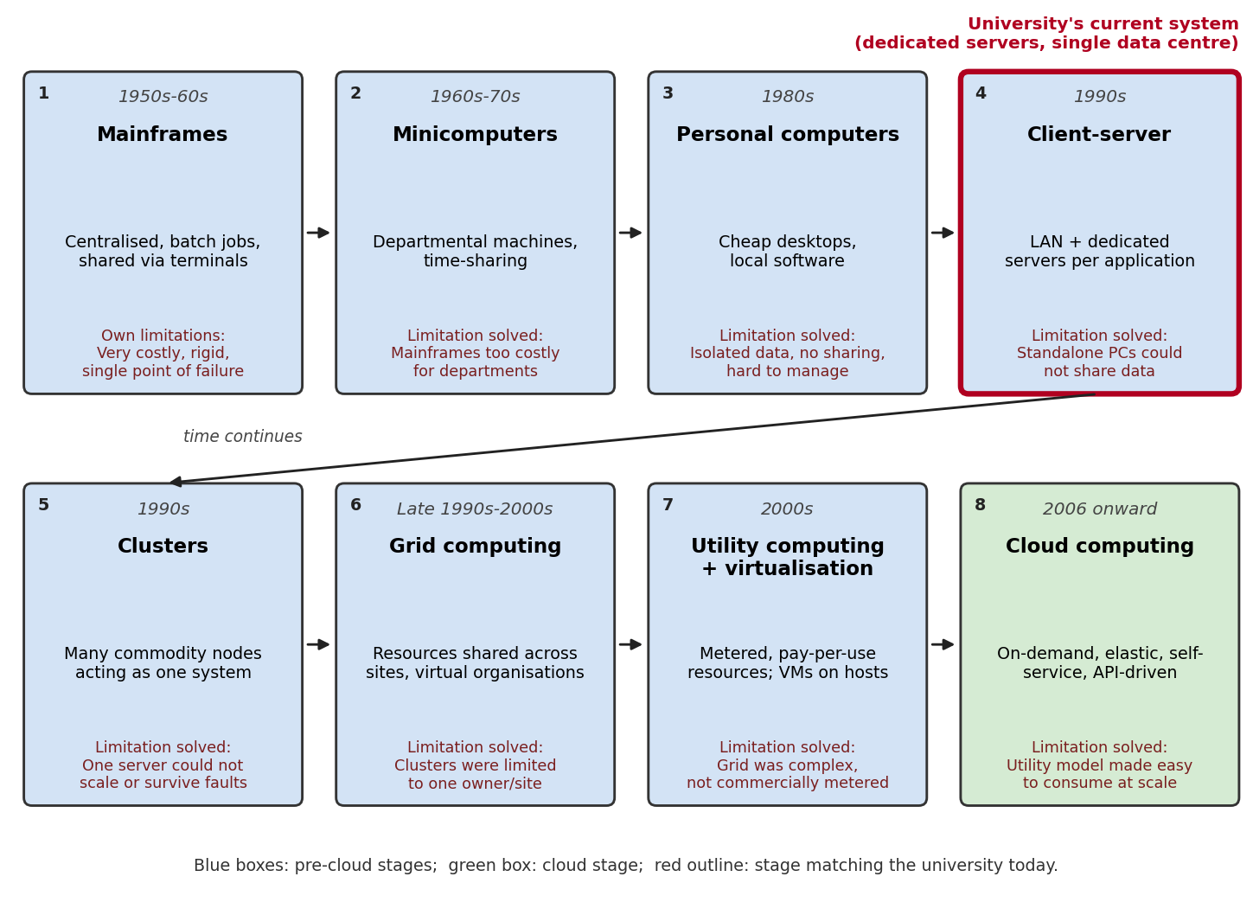
Figure 2.1: Evolution of computing infrastructure; red outline marks the university today
Table 2.1: Hardware advances that enabled cloud computing
Advance | Effect on cloud computing | Relevance to the university
Multi-core CPUs and virtualisation extensions (VT-x, AMD-V), mainstream from about 2005 | Many efficient VMs per host | Twelve servers consolidate onto a few hosts (Task 4)
Commodity x86 servers | Cheap, replaceable nodes; failures handled in software | Capacity rented by the hour
Faster, larger storage (SSD, object storage) | Durable low-cost replicated storage | Documents and backups in object storage
High-speed networks (10–100 Gbps, broadband) | Remote services feel local; cross-region replication | Mobile access and DR replication
Large data centres | Economies of scale; zones and regions | Multi-zone resilience the university cannot build alone

Current stage. The system is the client–server stage in its pre-virtualisation form: one application per dedicated server in the organisation’s own data centre. Evidence: low utilisation from no sharing; capacity by purchase (6–8 weeks); monolithic applications with no interfaces; one site with no DR; no metering. The migration therefore jumps across virtualisation and utility computing to cloud services.

Task 3: Analyse Internet Software Evolution
Table 3.1: Evolution of internet software and relevance to the university
Stage | Key technologies and traits | University relevance
Static web (1990s) | HTML, HTTP; read-only pages | Notice boards
Dynamic web | CGI, PHP, servlets with databases; page generated per request | Result and fee pages from SIS data
Web 2.0 (mid-2000s) | AJAX, rich clients; partial page updates | Responsive student dashboards
SOA | SOAP, WSDL, UDDI; reusable services with formal contracts | Reusable results and fees services
Mashups | REST, JSON, public APIs combined | Mobile app combining results, fees, library
Cloud-hosted apps | SaaS, microservices, containers, API gateways | Target state of the redesign

The browser is a universal client; HTTP carries requests with standard methods, status codes and caching; AJAX refreshes part of a page in the background; APIs expose business functions as JSON so that browser, app and partner use one service. For example, choosing a semester calls GET /api/v1/results/192510001 and refreshes only the grade table.
Table 3.2: Desktop, client–server and web-delivered software
Criterion | Desktop | Client–server | Web-delivered
Runs on | User’s computer | Client program plus central server | Browser plus remote servers
Updates | Per machine | Clients per machine, server centrally | Once, centrally
Scalability | Not applicable | Limited by purchased server | Elastic on cloud
Platform dependence | High | Medium–high | Low
Maintenance | Very high | High | Low for users
University example | Timetable spreadsheet | Current SIS and Library | Cloud LMS, web email, result API

Design impact. Applications should be API-first (versioned REST described with OpenAPI; OpenAPI Initiative, 2024), separate presentation, logic and data, keep services stateless so containers scale freely, use standard protocols, and decouple modules (Exam Portal, results and fees extracted from the SIS monolith). Commodity software (Email, LMS, Library) is rented, not built.

Task 4: Apply Server Virtualization
A hypervisor divides one physical host into isolated virtual machines (VMs): it presents virtual CPUs, memory, disks and network cards, schedules virtual CPUs onto physical cores, maps VM memory to physical memory and mediates device access. Processor extensions (Intel VT-x, AMD-V) let most guest instructions run directly on the CPU. Containers share the host kernel and are lighter but isolate less (Agasizade et al., 2024); containers inside VMs are a common compromise (Mavridis & Karatza, 2023).
Table 4.1: Hypervisor types and virtualisation techniques
Type / technique | How it works | Overhead / isolation | Examples
Type-1 (bare-metal) hypervisor | Runs directly on hardware; clustering, live migration | Low / strong | VMware ESXi, Hyper-V, Xen, KVM
Type-2 (hosted) hypervisor | Application on a host OS; per-machine management | Higher / strong | VirtualBox, VMware Workstation
Full virtualisation | Emulated hardware; unmodified guest | Moderate / strong | ESXi, VirtualBox
Para-virtualisation | Modified guest or drivers call the hypervisor directly | Low I/O cost / strong | Xen PV, virtio
Hardware-assisted | CPU virtualisation modes and nested page tables | Low / strong | VT-x/EPT, AMD-V/NPT
OS-level (containers) | Namespaces and cgroups share the host kernel | Very low / weaker | Docker, containerd

VMs or containers. Stateful, legacy or strongly isolated components run as VMs: SIS application monolith and database, Exam Portal database, LMS database, Library, Email and directory servers (target models: PaaS/DBaaS/SaaS). Stateless, bursty or new components run as containers: Exam Portal web tier, LMS web tier, new API/facade services, report and notification workers.

Consolidation calculation
Assumptions: 12 identical servers, each 1 server-equivalent (A1); average CPU use U_avg = 15%; target host utilisation U_t = 70% (headroom for spikes and overhead); each new host has the CPU of one legacy server (conservative) and 128 GB RAM; shared storage.
Step 1: D_cpu = 12 × 0.15 = 1.8 server-equivalents (28.8 cores)
Step 2: H_cpu = 1.80 ÷ 0.70 = 2.571 → 3 hosts
Step 3: memory = 12 × 64 × 0.30 = 230.4 GB; usable per host = 128 × 0.70 = 89.6 GB; H_mem = 2.571 → 3 hosts
Step 4: 3 hosts carry the load at 1.80 ÷ 3 = 60% utilisation (below 70%)
Step 5: N+1 spare → 3 + 1 = 4 hosts; with one failed, 1.80 ÷ 3 = 60%
Result
12 servers consolidate onto 3 hosts for the average load, or 4 hosts with N+1 fault tolerance (ratio 3:1).
Table 4.2: Sensitivity of the host count
Scenario | Demand | Hosts at 70%
+10% hypervisor overhead | 2.0 → 2.8 | 3
+10% overhead and +20% growth | 2.376 → 3.4 | 4
Peak week: any 5 servers at 95%, others at 15%: 5×0.95 + 7×0.15 | 5.8 → 8.3 (or 6.4 at a 90% ceiling) | 9 (or 7)

Peak caution. Four hosts saturate when several applications peak together (5.80 against 4 available); serving 63 peak days would need 7–9 hosts idle for the rest of the year. This justifies a small reserved baseline plus elastic cloud capacity (Tasks 8, 10). Risks and benefits: live migration and snapshots help maintenance; risks are noisy neighbours, host failure and weaker container isolation, mitigated by resource limits, N+1 hosts, patching and non-root containers.

Task 5: Apply Web Services
A web service exposes a function over standard web protocols, and in a service-oriented architecture applications are assembled from such services with published contracts. Cloud resources are themselves managed through web APIs.
Table 5.1: SOAP, WSDL, UDDI and REST
Aspect | SOAP / WSDL / UDDI | REST
Nature | SOAP: XML messaging; WSDL: XML contract; UDDI: service registry (largely obsolete) | Architectural style: resources and HTTP
Format and methods | XML only; mostly POST to one endpoint | JSON usually; GET, POST, PUT, DELETE on resource URLs
Security / caching | WS-Security message-level signing; hard to cache | TLS plus OAuth 2.0; native HTTP caching
Typical use | Banking and enterprise integration | Web and mobile APIs; described with OpenAPI

Four services use the example domain https://api.smartcampus.example, HTTPS and OAuth 2.0 bearer tokens, with errors in Problem Details form (Nottingham et al., 2023). Data are fictitious.
Table 5.2: Web services, style and justification
ID | Function and endpoint | Method | Style and justification
WS1 | Result lookup /api/v1/results/{registerNumber}?semester=5 | GET | REST: read-only, high volume, cacheable, light JSON for mobile.
WS2 | Library search /api/v1/library/books?title=cloud | GET | REST: paginated queries; public caching cuts load.
WS3 | Fee payment /api/v1/fees/payments | POST | REST: simple JSON for clients; idempotency key makes retries safe; card entry on a PCI DSS gateway (PCI Security Standards Council, 2024).
WS4 | Fee settlement batch /services/FeeSettlement | POST (SOAP 1.2) | SOAP: partner bank needs a WSDL contract, WS-Security and standard faults.

WS1 request and responses
GET /api/v1/results/192510001?semester=5 HTTP/1.1
Host: api.smartcampus.example
Authorization: Bearer <token>
HTTP/1.1 200 OK Content-Type: application/json
{"registerNumber":"192510001","name":"Student A","semester":5,"gpa":8.4,
"courses":[{"code":"CSA15","grade":"A"},{"code":"CSA12","grade":"B+"}]}
HTTP/1.1 404 Not Found Content-Type: application/problem+json
{"type":"about:blank","title":"Result not found","status":404,
"detail":"No result exists for register number 000000000."}

WS2 request and response
GET /api/v1/library/books?title=cloud&available=true&page=1&size=2 HTTP/1.1
HTTP/1.1 200 OK Cache-Control: public, max-age=300
{"page":1,"size":2,"total":14,"items":[
{"isbn":"978-0-00-000001-1","title":"Cloud Computing Basics","copiesAvailable":3},
{"isbn":"978-0-00-000002-8","title":"Distributed Systems Primer","copiesAvailable":1}]}
WS3 request and response
POST /api/v1/fees/payments HTTP/1.1
Idempotency-Key: 7c9e6679-7425-40de-944b-e07fc1f90ae7
{"registerNumber":"192510001","feeType":"SEMESTER_TUITION","amount":45000.00,
"currency":"INR","returnUrl":"https://portal.smartcampus.example/fees/done"}
HTTP/1.1 201 Created Location: /api/v1/fees/payments/PAY-20261031-0001
{"paymentId":"PAY-20261031-0001","status":"PENDING",
"redirectUrl":"https://gateway.example/pay/PAY-20261031-0001"}
WS4 SOAP request (WS-Security header omitted) and response
POST /services/FeeSettlement Content-Type: application/soap+xml
<soap:Envelope xmlns:soap="http://www.w3.org/2003/05/soap-envelope"
xmlns:fs="https://api.smartcampus.example/feesettlement"><soap:Body>
<fs:SubmitSettlementBatch><fs:batchId>BATCH-2026-10-31-01</fs:batchId>
<fs:paymentCount>2</fs:paymentCount>
<fs:totalAmount currency="INR">90000.00</fs:totalAmount>
</fs:SubmitSettlementBatch></soap:Body></soap:Envelope>
<soap:Envelope ...><soap:Body><fs:SubmitSettlementBatchResponse>
<fs:batchId>BATCH-2026-10-31-01</fs:batchId><fs:status>ACCEPTED</fs:status>
</fs:SubmitSettlementBatchResponse></soap:Body></soap:Envelope>

Task 6: Analyse the Service Models: IaaS, PaaS and SaaS
IaaS supplies virtual compute, storage and networking; PaaS adds the operating system and runtime so the customer manages code and data; SaaS delivers the whole application. In every model the customer keeps responsibility for its data, identities and access (Microsoft, 2025a).
Table 6.1: Layer-wise responsibility (Customer = university; Provider = cloud provider)
Layer | On-premise | IaaS | PaaS | SaaS
Applications | Customer | Customer | Customer | Provider
Data, identities and access | Customer | Customer | Customer | Customer
Runtime and middleware | Customer | Customer | Provider | Provider
Operating system | Customer | Customer | Provider | Provider
Virtualisation, servers, storage, network | Customer | Provider | Provider | Provider

Table 6.2: Application mapping and justification
Application | Model | Justification (alternatives rejected)
SIS | PaaS (interim IaaS re-hosting) | Custom, sensitive and the base for mobile and college APIs. SaaS has no product matching its rules; IaaS keeps OS and database patching and manual scaling. PaaS gives managed runtime, autoscaling and database. The monolith is first re-hosted on VMs, with an API layer built in front (strangler pattern).
LMS | SaaS | Standard category with mature hosted offerings and SSO; running it ourselves adds upgrade and peak-scaling work for no advantage. Trade-off: less customisation.
Library | SaaS | Small, steady cataloguing and circulation; no case for dedicated infrastructure; search exposed by vendor API or WS2.
Exam Portal | PaaS | Sharpest peaks and integrity-critical custom logic. SaaS testing tools reduce control of exam rules; IaaS needs hand-built autoscaling. PaaS containers, managed database and queue scale in minutes and can be pre-scaled.
Email | SaaS | Commodity with no university logic; needs high availability and spam defence; mature education offerings. Confirm data-export rights.

IaaS remains the foundation (network, load balancing, object storage, VPN, interim VMs). Real examples: IaaS Amazon EC2; PaaS Google Cloud Run (used in Task 9); SaaS Google Workspace for Education.
Table 6.3: Comparison of the service models
Criterion | IaaS | PaaS | SaaS
Control | Highest | Code and configuration | Settings and data
Cost pattern | Per VM and storage plus staff | Per instance or request | Per-user subscription
Scalability | Must be engineered | Built-in autoscaling | Vendor-managed, plan limits
Maintenance | High | Low–medium | Minimal
Lock-in | Low–medium | Medium–high (lower with containers) | High; export rights essential

Task 7: Examine XaaS
XaaS generalises IaaS, PaaS and SaaS: any capability packaged, metered and delivered over a network can be consumed as a service, which moves specialist operational work to the provider.
Table 7.1: XaaS variants and university use
Variant | Example offerings | University use | Main risk
DaaS (Desktop) | Azure Virtual Desktop; Amazon WorkSpaces | Computer-lab desktops | Latency; licence cost
MBaaS (Mobile backend) | Firebase; AWS Amplify | Quick app backend | Strong lock-in
FaaS (Function) | AWS Lambda; Azure Functions | Receipts, notifications, nightly jobs | Cold starts; limits
DBaaS (Database) | Amazon RDS; Cloud SQL | SIS and Exam Portal databases | Less OS-level control
SECaaS / IDaaS | Microsoft Entra ID; Cloudflare WAF | Single sign-on, MFA, API protection | Trust concentration
DRaaS (Disaster recovery) | AWS Elastic Disaster Recovery; Azure Site Recovery | Recovery region for SIS and Exam Portal | Failover must be tested

Selection 1: DBaaS. The SIS and Exam Portal databases are the most valuable and failure-sensitive assets, and administration (patching, backups, replication, failover) is continuous skilled work. A managed database gives point-in-time recovery, a synchronous standby in a second zone with automatic failover and read replicas, directly supporting the 99.9% target and allowing one fewer infrastructure engineer in Task 10. An open-source engine such as PostgreSQL limits lock-in.
Selection 2: DRaaS. The university has no recovery site and a second data centre would double CapEx. DRaaS replicates data to a second Indian region and runs a minimal footprint (pilot light): RPO 15 minutes, RTO 4 hours in the original design, tightened to 5 and 30 minutes in Task 11, at about ₹6 lakh a year and testable without disturbing production.
Risks of over-reliance. Availability multiplies along a chain: three services at 99.95% give 0.9995³ = 99.85%, about 13.1 hours of downtime a year, already above the 8.76-hour budget of 99.9% (Amazon Web Services, 2024). Other risks are lock-in (use containers, open engines, exportable backups), shared-responsibility gaps (matrix per service; NIST, 2024), cost sprawl (budgets, tagging), residency (region pinning; Government of India, 2023) and integration complexity (single sign-on, one API gateway).

Task 8: Design the Cloud Solution Architecture
Request flow. Users reach the platform over HTTPS; DNS, CDN and a web application firewall cache static content, terminate TLS and block attacks. A Layer-7 load balancer spreads traffic across two zones. All web, mobile and partner calls pass the API gateway, which authenticates tokens, rate-limits and routes. The application tier (auto-scaling PaaS containers, at least three per zone) runs SIS services and the Exam Portal. Data sits in a managed database with a synchronous standby in the second zone and in versioned, encrypted object storage. Email, LMS and Library are SaaS sharing one identity provider. Database changes and objects are copied to a second Indian region, where the replica is promoted and the application tier is launched from templates on disaster.
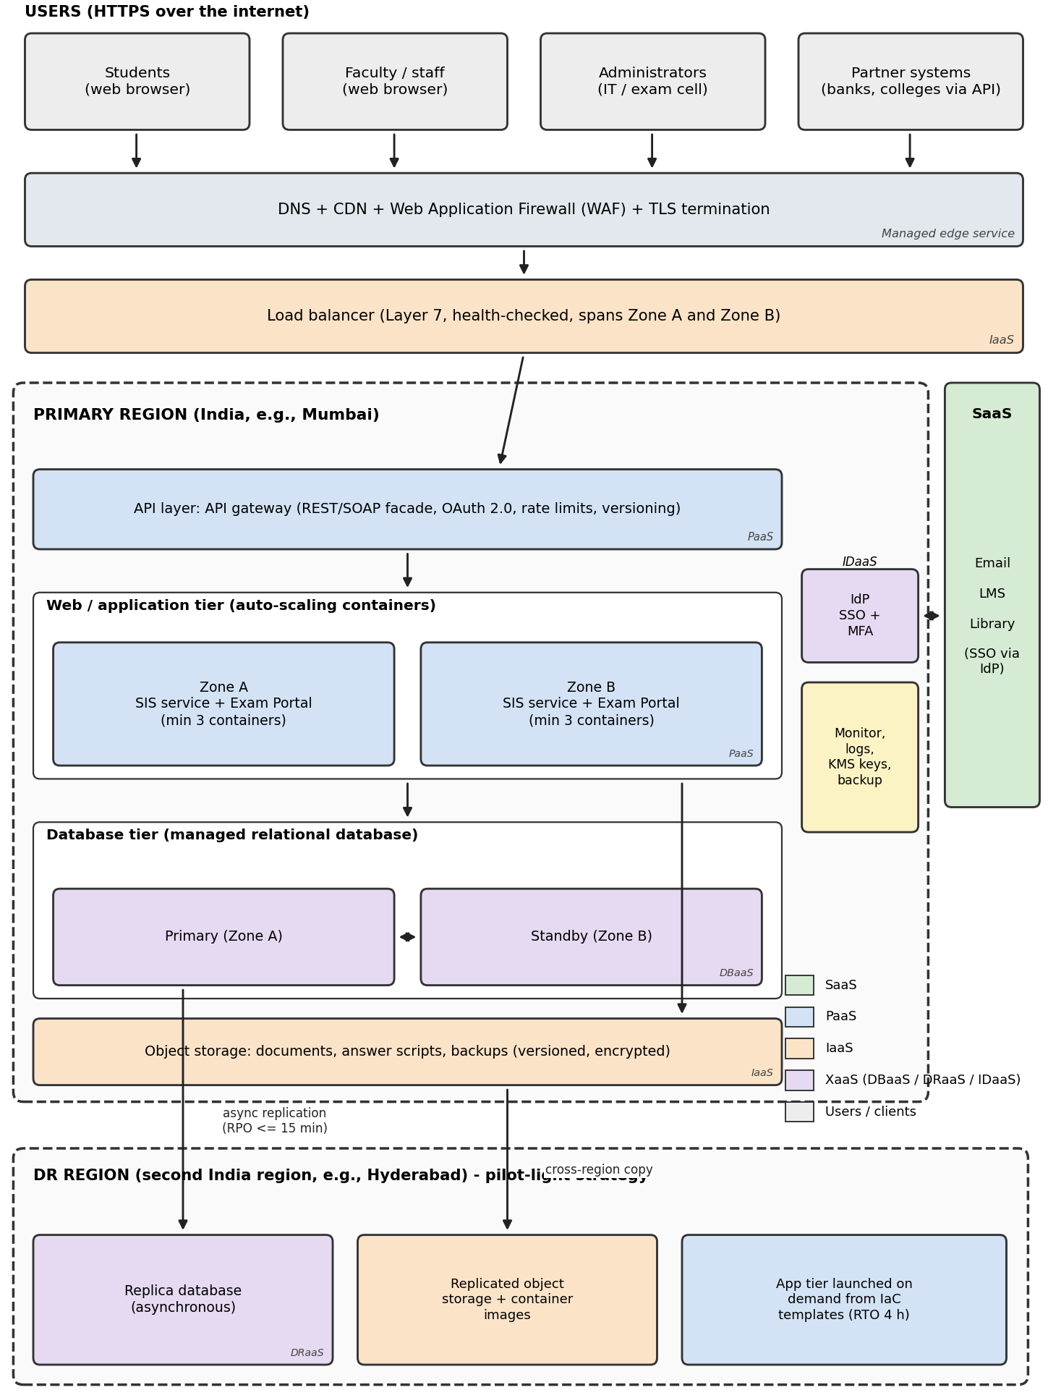
Figure 8.1: Proposed architecture: users, edge, load balancer, API layer, application tier, database, storage, SaaS, identity and DR region
Table 8.1: Components, deployment model, service model and justification
Component | Deployment / service model | Justification
Edge (DNS, CDN, WAF) | Public / managed service | Absorbs spikes and attacks before the application.
Load balancer | Public / IaaS | Multi-zone distribution, health checks, prerequisite for elasticity.
API gateway | Public / PaaS | Single controlled entry for mobile and partners.
Application tier | Public / PaaS (containers) | Custom logic with managed runtime and autoscaling; portable.
Database | Public / DBaaS | Managed backup, patching, failover, replication.
Object storage | Public / IaaS | Durable, cheap storage with versioning.
Email, LMS, Library | Public / SaaS | Vendor-maintained commodity applications.
Identity | Public / IDaaS | SSO and MFA across SaaS and PaaS.
DR region | Public (second region) / DRaaS | Replicated data and templates without a second data centre.
Campus link | Hybrid (transitional) / IaaS VPN | Reaches legacy servers until retired.

Elasticity. From A3, 200 req/s needs 200 ÷ (12 × 0.70) = 23.8 → 24 containers, plus 2 spares = 26 at peak, against 6 on a normal day. Scheduled scaling raises the minimum before admissions, results and exam slots; scale-out triggers at 60% CPU, scale-in below 30% for 15 minutes, with a cap of 40; a queue smooths exam submissions (cf. The Kubernetes Authors, 2025). Security and availability: SSO with MFA and least-privilege roles; TLS 1.2+ and AES-256 at rest with managed keys; private subnets and WAF; daily snapshots kept 35 days with point-in-time recovery; two-zone deployment with automatic database failover; pilot-light DR (RPO 15 min, RTO 4 h); central logging aligned to NIST CSF 2.0 (NIST, 2024); Indian regions and consent/breach processes under the DPDP Act (Government of India, 2023). The design is provider-neutral; its main limitation is shown in Task 11.

Task 9: Hands-on Implementation and Documentation
Objective. Implement result lookup (WS1) as a Flask REST API (Pallets, 2025), package it as a Docker container (Task 4), then deploy the same image to the managed PaaS Google Cloud Run (Task 6) and test it with curl or Postman. The server binds to the PORT variable as Cloud Run requires (Google Cloud, 2025a); the Dockerfile uses a slim image, cached dependency layer and non-root user (Docker, Inc., 2025). Files: app.py, requirements.txt, Dockerfile, tests/test_app.py (also in the supplied zip).
app.py
"""Smart Campus PoC - Result Lookup REST API (CSA15 Assignment 1, Task 9)."""
import os
from flask import Flask, jsonify, request
app = Flask(__name__)
# Fictitious sample data only - no real student records are used.
RESULTS = {
"192510001": {"name": "Student A", "semester": 5, "gpa": 8.4,
"courses": [{"code": "CSA15", "grade": "A"},
{"code": "CSA12", "grade": "B+"}]},
"192510002": {"name": "Student B", "semester": 5, "gpa": 7.9,
"courses": [{"code": "CSA15", "grade": "B+"},
{"code": "CSA12", "grade": "B"}]},
}
def problem(status, title, detail):
"""Error body following RFC 9457 (application/problem+json)."""
body = jsonify({"type": "about:blank", "title": title,
"status": status, "detail": detail})
body.status_code = status
body.headers["Content-Type"] = "application/problem+json"
return body
@app.get("/health")
def health():
return jsonify({"status": "UP", "service": "results-api"}), 200
@app.get("/api/v1/results/<reg_no>")
def get_result(reg_no):
record = RESULTS.get(reg_no)
if record is None:
return problem(404, "Result not found",
f"No result exists for register number {reg_no}.")
sem = request.args.get("semester", type=int)
if sem is not None and sem != record["semester"]:
return problem(404, "Semester not found",
f"No semester {sem} result for {reg_no}.")
return jsonify({"registerNumber": reg_no, **record}), 200
if __name__ == "__main__":
port = int(os.environ.get("PORT", 8080))
app.run(host="0.0.0.0", port=port)
requirements.txt and Dockerfile
Flask==3.1.0
gunicorn==23.0.0
pytest==8.3.4
FROM python:3.12-slim
ENV PYTHONDONTWRITEBYTECODE=1 PYTHONUNBUFFERED=1
WORKDIR /app
COPY requirements.txt .
RUN pip install --no-cache-dir -r requirements.txt
COPY app.py .
RUN useradd --create-home appuser
USER appuser
EXPOSE 8080
CMD ["sh", "-c", "gunicorn --bind 0.0.0.0:${PORT:-8080} --workers 2 app:app"]

Part A: build, run and test locally
python -m pip install -r requirements.txt && python -m pytest -q # optional unit tests
docker build -t smartcampus-results:1.0 .
docker run -d --name results-api -p 8080:8080 smartcampus-results:1.0
docker ps # container Up, port 8080
curl -i http://localhost:8080/health
curl -i http://localhost:8080/api/v1/results/192510001
curl -i http://localhost:8080/api/v1/results/000000000
curl -i "http://localhost:8080/api/v1/results/192510001?semester=6"
docker stop results-api && docker rm results-api
EXPECTED OUTPUT (reference only, not an actual result; header lines and key order may vary)
pytest: 3 passed
/health 200 {"service":"results-api","status":"UP"}
result found 200 {"courses":[{"code":"CSA15","grade":"A"},{"code":"CSA12","grade":"B+"}],
"gpa":8.4,"name":"Student A","registerNumber":"192510001","semester":5}
unknown number 404 application/problem+json
{"detail":"No result exists for register number 000000000.","status":404,
"title":"Result not found","type":"about:blank"}
semester=6 404 {"detail":"No semester 6 result for 192510001.","status":404,
"title":"Semester not found","type":"about:blank"}
Part A – Local Docker Deployment
- Docker image built successfully using docker build -t results-api:1.0
- Docker image verified using docker images. Image: results-api:1.0 (approximately 191.71 MB).
- Container started successfully as results-api-container with port mapping 8080:8080.
- Health endpoint (/health) returned HTTP 200:
{"service":"results-api","status":"UP"}

- Valid result endpoint (/api/v1/results/192510001) returned HTTP 200 with student details and GPA 8.4.
- Pytest execution completed successfully: 3 tests passed.

Part B: deploy the same container to a PaaS (Google Cloud Run)
Cloud Run builds the image from the Dockerfile and deploys it (Google Cloud, 2025b). Check current free-tier and billing terms and set a budget alert first. asia-south1 (Mumbai) keeps data in India; --allow-unauthenticated is for the demo only.
gcloud auth login
gcloud config set project <YOUR_PROJECT_ID>
gcloud services enable run.googleapis.com cloudbuild.googleapis.com artifactregistry.googleapis.com
gcloud run deploy uni-results-api --source . --region asia-south1 --allow-unauthenticated --max-instances 2
curl -i <SERVICE_URL>/health ; curl -i <SERVICE_URL>/api/v1/results/192510001
gcloud run services delete uni-results-api --region asia-south1 # clean-up to avoid cost
Expected: deployment prints a Service URL of the form https://uni-results-api-<hash>-<region-code>.a.run.app, and the curl bodies match Part A; the first call after idle may be slower (cold start).

Part B – Deployment on Google Cloud Run
Deployment configuration:
- Platform: Google Cloud Run
- Service name: results-api
- Region: asia-south1 (Mumbai)
- Container port: 8080
- Container image: results-api:1.0
Deployment result:
Service: results-api
Platform: Google Cloud Run
Region: asia-south1
Status: Ready
Container port: 8080
Health-check response:
Request:
GET /health
Response:
{
"service": "results-api",
"status": "UP"
}
HTTP status: 200 OK
Student-result response:
Request:
GET /api/v1/results/192510001
Response:
{
"courses": [
{
"code": "CSA15",
"grade": "A"
},
{
"code": "CSA12",
"grade": "B+"
}
],
"gpa": 8.4,
"name": "Student A",
"registerNumber": "192510001",
"semester": 5
}
HTTP status: 200 Ok
Table 9.1: Test plan and evidence log (student to complete)
ID | Test | Expected | Actual | Pass/Fail | Fig.
T1 | Unit tests | 3 passed | 3 tests passed in 1.74 seconds | Pass | 9.4
T2 | Image build and container running | Image listed; status Up on 8080 | Image results-api:1.0 created; container running on port 8080 | Pass | 9.1
T3 | Health and result (local) | 200 with expected JSON | Health and result endpoints returned HTTP 200 with expected JSON | Pass | 9.2
T4 | Failure cases (local) | 404 problem+json | Both failure cases returned HTTP 404 with problem JSON | Pass | 9.3

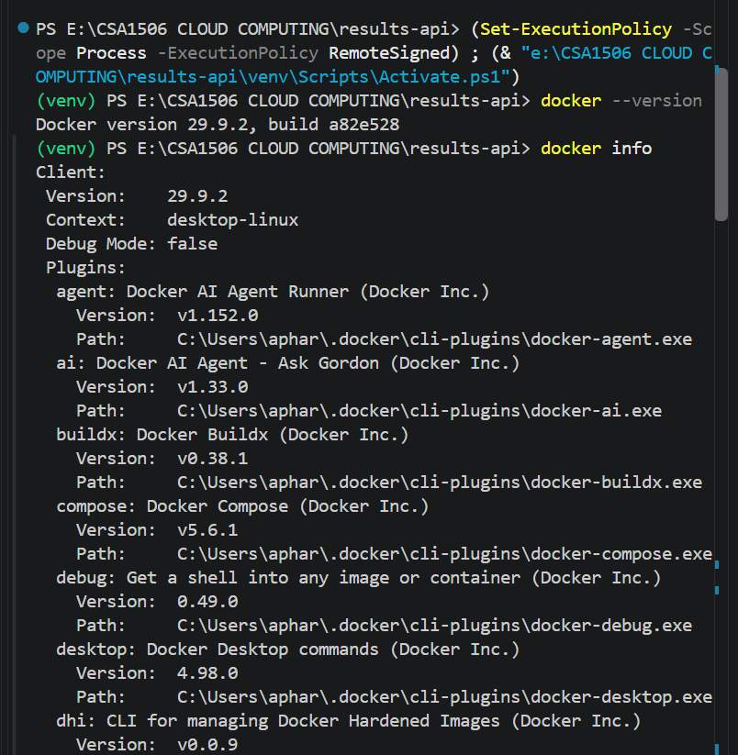
Figure 9.1: Terminal showing
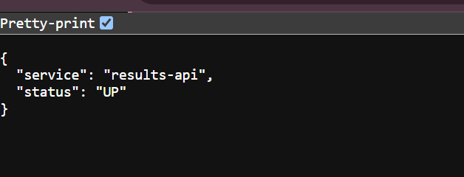

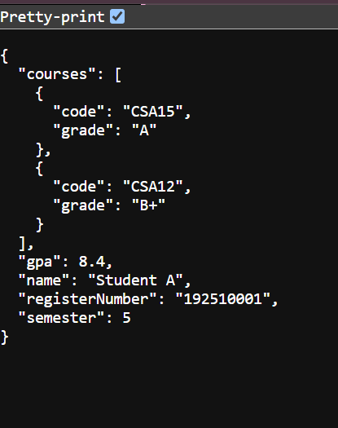
Figure 9.2: curl or Postman response for
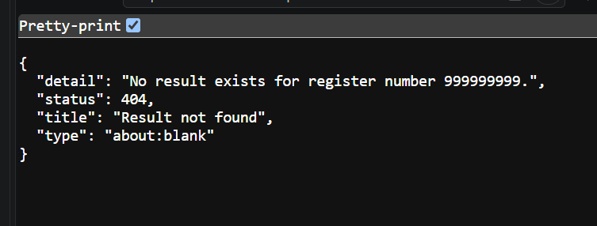
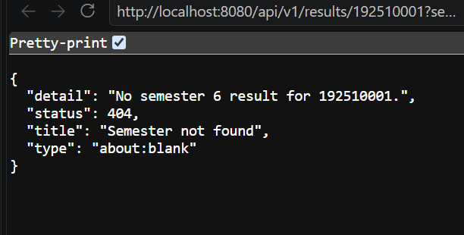
Figure 9.3: Responses for the unknown register number and wrong semester
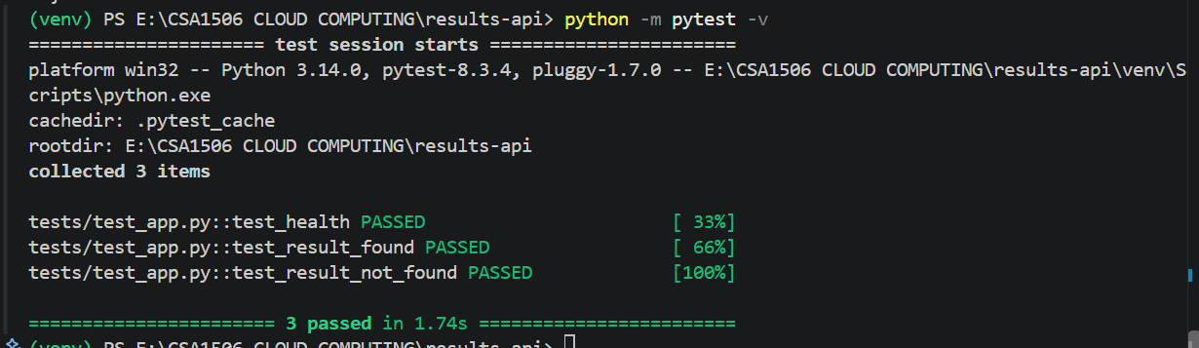Figure 9.4: Output of pytests
Issues faced : Anticipated, not experienced: Docker daemon not running (start Docker Desktop); port 8080 busy (use -p 8081:8080); Cloud Run start-up failure if the server ignores PORT; HTTP 403 if the service is not public; billing or APIs not enabled. Limits: the proof-of-concept covers one containerised service on a PaaS; zones, managed database, autoscaling and DR are validated by design analysis (Tasks 8, 10, 11) and the planned tests in Task 11.

Task 10: Evaluate and Recommend the Final Solution
Three options are costed for the same workload: A on-premise (7 hosts sized for the peak, since 5.80 server-equivalents ÷ 0.90 = 6.4, plus storage, network and a small DR rack); B IaaS (12 reserved VMs, peak VMs on demand, self-managed databases, pilot-light DR); C the Task 8 design (SaaS, PaaS containers, DBaaS, API gateway, DRaaS). Assumptions (A2, A5): constant prices; CapEx and one-time costs in Year 0; peak 1,512 h a year; host ₹6 lakh; IaaS VM ₹7,000/month reserved, ₹14.38/h on demand; PaaS instance ₹5,500/month (₹7.53/h); managed database ₹1.0 lakh/month; storage ₹5/GB-month (B), ₹2.5/GB-month (C); SaaS ₹14.8 lakh/year (Email 2.4, LMS 10, Library 2.4); staff ₹8 lakh per FTE (A 4, B 3, C 2).
B: 12 × 7,000 × 12 = ₹10.08 L; 12 × 1,512 × 14.38 = ₹2.61 L; 16,000 GB × 5 × 12 = ₹9.60 L
C: 6 × 5,500 × 12 = ₹3.96 L; 20 × 1,512 × 7.53 = ₹2.28 L; 10,240 GB × 2.5 × 12 = ₹3.07 L
Table 10.1: Three-year cost comparison (₹ lakh)
Cost element | A: On-premise | B: IaaS | C: PaaS/SaaS
One-time (hardware and DR rack / migration and training) | 110.0 | 18.0 | 23.0
Compute (hosts support, VMs or containers incl. peak) | 10.4 | 12.7 | 6.2
Database, storage and backup | 2.0 | 9.6 | 15.1
Facility, network, edge, egress, DR, licences, SaaS | 21.0 | 22.6 | 28.0
Staff | 32.0 | 24.0 | 16.0
Annual running cost | 65.4 | 68.9 | 65.3
Three-year total (Year 0 + 3 × annual) | 306.2 | 224.7 | 218.9

Option A costs ₹87.3 lakh more than C (29% higher) because it buys hardware for 63 peak days and needs most staff. B and C differ by only ₹5.7 lakh (2.6%), within price uncertainty, so cost alone does not separate them. Sensitivity: with non-staff cloud prices +20%, C = ₹248.5 lakh and B = ₹251.6 lakh, still below A at ₹306.2 lakh; at +40%, C = ₹278.1 lakh approaches A, which is why budgets and reserved commitments are in the plan.
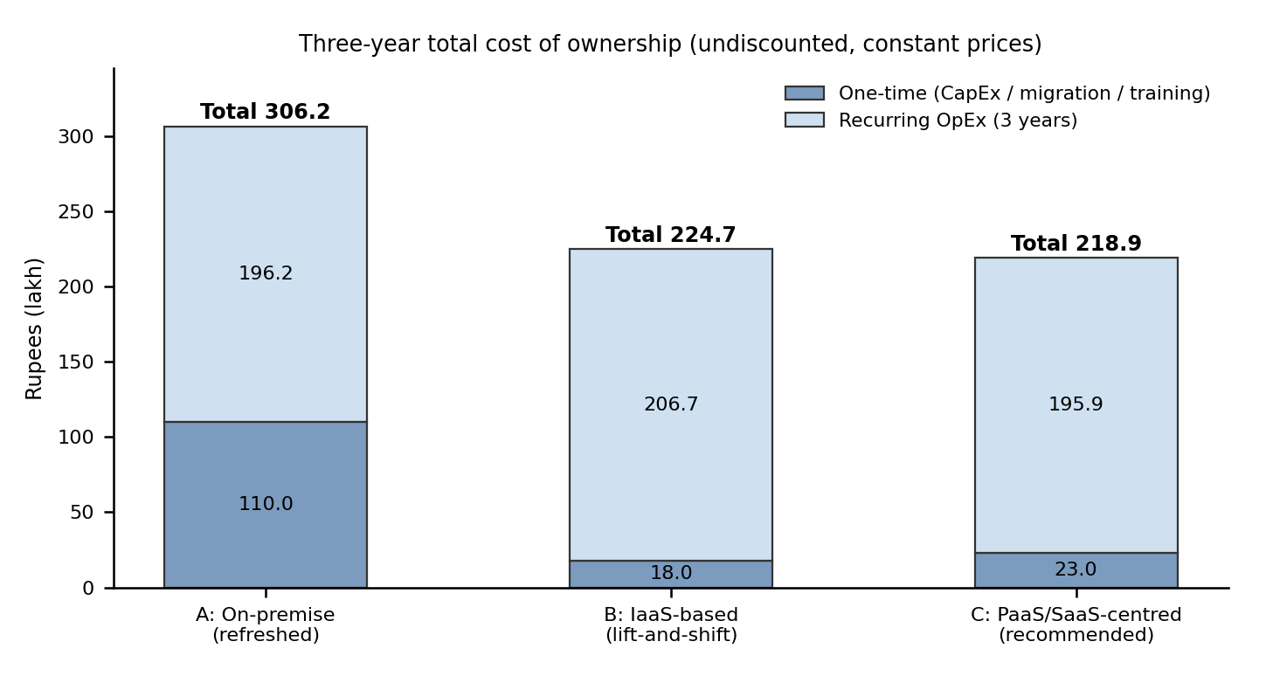
Figure 10.1: Three-year total cost of ownership (₹ lakh)
Table 10.2: Weighted evaluation (scores 1–5; weighted score out of 100 = Σ weight × score ÷ 5)
Criterion | Weight | A | B | C
Cost | 25 | 2 | 3 | 4
Scalability | 20 | 1 | 4 | 5
Availability | 20 | 2 | 4 | 5
Security/compliance | 15 | 3 | 3 | 4
Management effort | 10 | 2 | 3 | 4
Exit / lock-in | 10 | 5 | 4 | 3
Weighted score |  | 45 | 70 | 86

Table 10.3: Risks and mitigation
Risk | Mitigation
Vendor lock-in | Containers, PostgreSQL-compatible managed database, OpenAPI contracts, exportable backups, contractual exit assistance, yearly exit review.
Data privacy and residency | Indian regions only; encryption with managed keys; least privilege; DPDP-aligned consent and breach process (Government of India, 2023); card data kept at a PCI DSS gateway (PCI Security Standards Council, 2024).
Downtime | Multi-zone deployment, managed database failover, DRaaS with quarterly drills, change freeze in exam windows.
Skills gap and cost overrun | Training (₹3 lakh), pilot application first, runbooks; budgets, alerts, tagging, autoscaling caps, reserved baseline.

Recommendation
Adopt Option C in two Indian regions with a temporary hybrid link, delivered in phases: lowest three-year cost (₹218.9 lakh), highest weighted score (86/100), best elasticity for peaks, managed multi-zone availability, API readiness and least operating effort. The provider is chosen by criteria, not popularity: two India regions with replication, required managed services, published SLAs, education pricing and SaaS export terms, open standards for exit, and local skills; quotations from two or three shortlisted providers decide.

Table 10.4: Phased roadmap (months from start; scheduled outside admissions, results and exam windows; Microsoft, 2025c)
Phase | Months | Scope and reason for order | Exit / rollback
0 Foundation | 1–2 | Landing zone, VPN, SSO, budgets, training | Security review passed
1 Email → SaaS | 3–4 | First: commodity, no custom code, low coupling; frees 2 servers; rollback by restoring mail routing | Mailboxes verified; old servers read-only 30 days
2 Library, LMS → SaaS | 4–7 | Low business risk; before next term; frees 4 servers | Data reconciled; user sign-off
3 Exam Portal → PaaS | 7–9 | Biggest elasticity gain; ready before next exams; load-tested | Load test at 1.5× peak; exam-cell approval
4 SIS → PaaS + API | 9–13 | Most sensitive, so last: re-host, API gateway, extract services, enable DRaaS | One result cycle in parallel run
5 Decommission | 13–14 | Retire 12 servers; DR drill; cost review | Sign-off

Task 11: Re-evaluate and Adapt the Design (Day-4 Design Challenge)
Decision: MODIFY
Keep the service-model mix (SaaS, PaaS, DBaaS, DRaaS) and container-first virtualisation; change the architecture by adding a tenant-aware API layer, three-zone orchestration, cache and queue, a read replica, warm-standby DR with automated failover, and multi-tenant isolation with cost controls. Redesign would discard sound work; keeping the design unchanged fails the capacity and availability arithmetic.

11.1 Impact Analysis
Table 11.1: What changed
Dimension | Before | After Day 4
Peak load | 200 req/s | 2,000 req/s (10×)
Users and clients | 25,000 students; browsers | About 85,000 students (A4); mobile app, college systems, payment callbacks
Availability | Best effort (about 99.7% by SLA arithmetic) | 99.9%: 8.76 h per year, 43.8 min per month
Tenancy and budget | One organisation; moderate budget | 40 colleges plus the university; limited budget

Why APIs become critical. They are the only interface for the mobile app and colleges, so colleges never touch the database; the gateway is the security boundary (authentication, scopes, per-tenant quotas), versioned contracts let clients evolve independently, caching and metering sit there, and API availability and latency become the main service indicators.
Multi-tenancy. Siloed stacks per college (strongest isolation) mean 40 deployments and break the budget; schema-per-college is a bridge option for special cases; the pooled model (shared application and database with tenant_id on every row) is selected (Microsoft, 2025b). Controls: tenant ID as a token claim checked at the gateway; database row-level security (PostgreSQL Global Development Group, 2025); per-college credentials, scopes and rate limits; per-tenant storage prefixes and optional per-tenant keys; audit logs; cross-tenant penetration tests; card data kept at a PCI DSS gateway (PCI Security Standards Council, 2024); DPDP compliance (Government of India, 2023).

11.2 Evaluation of the Original Design
Capacity. SaaS is scaled by vendors; the constraints are containers and the database (A3):
Containers = 2,000 ÷ (12 × 0.70) = 238.1 → 239; one of two zones lost → 239 × 2 = 478
Database = 8 vCPU × 0.50 × 10 ÷ 0.70 = 57.1 → 64 vCPU on one primary
About 478 containers and a 64-vCPU database are only possible on paper, and the original peak design (26 containers) could not tolerate a zone loss at peak.
Availability. 99.9% allows 8,760 × 0.001 = 8.76 hours a year. Request availability is the product of the chain (Amazon Web Services, 2024):
A_orig = 0.9999 (edge) × 0.9999 (LB) × 0.9995 (gateway) × 0.9995 (app, 2 zones) × 0.9995 (DB) × 0.999 (identity) = 0.99730
This is 99.73%, about 23.6 hours of downtime a year (2.7× the budget). Auto-scaling protects against load, not component or regional failure, and manual DR (RTO 4 h) would alone consume about half the annual budget. SLAs are minimums, but the design must be justified on what is guaranteed.
Cost. Brute-force 10× scaling costs about ₹240.4 lakh a year against ₹65.3 lakh today (3.7×), mostly database (₹96.0 lakh) and peak containers. Alternatives: adopt CDN/cache (about 60% fewer requests reach the application), API management, managed orchestration, FaaS for background work, a queue and a read replica; reject MBaaS (lock-in), permanent hybrid (needs 10× hardware and a DR site) and multi-cloud active-active (cost, skills).

11.3 Adaptation
Table 11.2: Architecture changes (original → revised)
Component | Original (Task 8) | Revised
Edge | DNS, CDN, WAF | Adds health-checked DNS failover, DDoS protection, caching of read APIs
API layer | Gateway with rate limits | Tenant-aware: OAuth 2.0 client credentials, JWT validation, per-college quotas, analytics
Application tier | 2 zones, 6–26 containers | Managed orchestration, 3 zones, 9–144 containers, autoscaling (The Kubernetes Authors, 2025)
Async and cache | None | Message queue, managed cache, functions for receipts and notices
Database | Primary + standby, 8 vCPU | Primary 16 vCPU, standby, read replica, tenant_id with row-level security
Disaster recovery | Pilot light, manual, RTO 4 h, RPO 15 min | Warm standby, automated DNS failover, RTO 30 min, RPO 5 min
Identity | SSO | Adds college tenants; tokens validated at the gateway, taking identity off the per-request path
Service mix and virtualisation | SaaS, PaaS, DBaaS, DRaaS; containers | SaaS unchanged; PaaS gains orchestration and API management; XaaS adds cache, queue, FaaS; containers spread over three zones; VMs only for legacy until retired; hybrid link temporary

Revised roadmap. The API gateway and a read-only student-record API in front of the legacy SIS move to Phases 0–1 (strangler pattern); fee payment and further colleges follow after load and failover tests; Email, Library, LMS and Exam Portal proceed as in Task 10.

11.4 Evidence-Based Defence
Peak load reaching the application = 2,000 × (1 − 0.60 cache hit) = 800 req/s → 800 ÷ 8.4 = 95.2 → 96
Three zones, one zone may fail: 96 × 3 ÷ 2 = 144 → 144 containers at peak; normal day 34.3 req/s → 9
Database = 8 × 0.50 × (800 ÷ 200) ÷ 0.70 = 22.9 → 16 vCPU primary + 8 vCPU read replica
Cache and read replica cut the database from 64 to 24 vCPUs and peak containers from 478 to 144. The 60% cache-hit rate and 12 req/s per container are assumptions to be confirmed by load test.
Availability. Identity leaves the per-request path (the gateway validates signed tokens locally) and the application tier spans three zones. With failover success probability p = 0.9:
A_region = 0.9999 × 0.9999 × 0.9995 × 0.9999 × 0.9995 = 0.99870 (11.4 h/yr: one region still misses 99.9%)
A_total = A_region + (1 − A_region) × p × A_region = 0.999869 (99.987%, 1.2 h/yr)
Table 11.3: Annual run cost (₹ lakh per year)
Cost line | Original, current load | Original scaled 10× | Revised, 10×
Compute (containers, peak, orchestration) | 6.2 | 66.5 | 23.1
Database (DBaaS, incl. replicas) | 12.0 | 96.0 | 38.4
Storage, edge, cache, egress, DR, security tooling | 16.3 | 39.1 | 42.0
SaaS licences | 14.8 | 14.8 | 14.8
Staff (revised adds a platform engineer) | 16.0 | 24.0 | 24.0
Total per year | 65.3 | 240.4 | 142.4

The revised design serves ten times the peak for ₹142.4 lakh a year (2.2× the original, 41% below brute force). A 30% one-year commitment discount on baseline containers and the primary database saves ₹9.0 lakh (₹133.4 lakh). The extra ₹77.1 lakh (₹68.1 lakh after discount) is about ₹1.93 lakh (₹1.70 lakh) per college a year, which a platform fee proposed to the university could recover (not counted as income here).
Trade-offs. Lock-in (managed gateway, orchestration, DR): containers, PostgreSQL-compatible database, OpenAPI and infrastructure-as-code. Complexity: managed services only, runbooks, failover drills. Eventual consistency (cache, replica): used only for reads; payments and exam submissions go to the primary. Validation plan (planned, not executed): load test to 2,000 req/s confirming cache-hit and per-container figures; remove one zone mid-test; full region failover drill measuring RTO and RPO; cross-tenant isolation tests; pass criteria 99.9% successful requests, RTO ≤ 30 minutes, no cross-tenant exposure.
Final defence
The original design cannot reach 99.9% (99.73%) or scale economically to 2,000 req/s (₹240.4 lakh a year). The modified design meets the targets on stated assumptions (99.99% availability, 144 containers at peak, 24 database vCPUs) for ₹142.4 lakh a year, isolates 40 tenants with layered controls, keeps the service mix of Tasks 6–8, and can be verified by tests defined in advance.

Overall Conclusion
The university’s problems stem from a dedicated-server client–server architecture, and cloud characteristics answer each of them. The recommended solution is a PaaS/SaaS-centred public cloud in two Indian regions with a temporary hybrid link: 12 servers consolidate onto 3–4 hosts in the interim (Task 4); SIS and Exam Portal run on PaaS and Email, LMS and Library on SaaS (Task 6) with DBaaS and DRaaS (Task 7); Option C costs ₹218.9 lakh over three years against ₹306.2 lakh on-premise (Task 10); and the Day-4 changes are met by a modified architecture at ₹142.4 lakh a year (Task 11).

